# Skill Set

Backend: Java8, Spring Boot, Spring data, SpringMVC, Torpedo

Frontend: Angular Material

DB: Oracle

Weather Api: <http://openweathermap.org/current>

IDE: IntelliJ

# Design Idea.

1. The application is built upon RESTful API which makes client code totally decoupled from server code.
2. Using Spring MVC to achieve restful API.
3. Using Spring data to access DB, and Torpedo to achieve [type safe hibernate query](https://www.google.com.au/url?sa=t&rct=j&q=&esrc=s&source=web&cd=1&cad=rja&uact=8&ved=0ahUKEwi7nuTAzqnMAhViIaYKHYhFDiIQFggeMAA&url=http%3A%2F%2Ftorpedoquery.org%2F&usg=AFQjCNEEzsU8krcIQWrmhIIk4oee1ih9cg&sig2=s0nCNxopkhp-Xwwlh6Q7JQ&bvm=bv.119745492,d.dGY).
4. Using Spring boot to achieve rapid development with less configuration and embed tomcat.
5. Using Angular Material to implement client code which is easy to organize layout and provide Responsive web design. By using standard components of angular material, it is easy to achieve consistent style.

The business logic can be divided into two parts.

Part 1:

Get city Info from server side, all cities info are stored in DB, which make it is easy to extend.

Part 2:

Get weather Info By city ID from open API

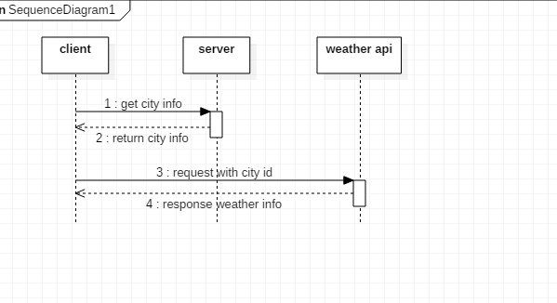

# Screenshot

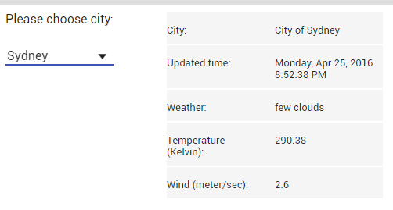

Can change to below style automatically when the window is shrined.

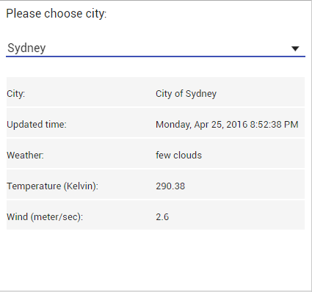

# Project Structure:

